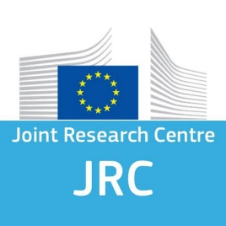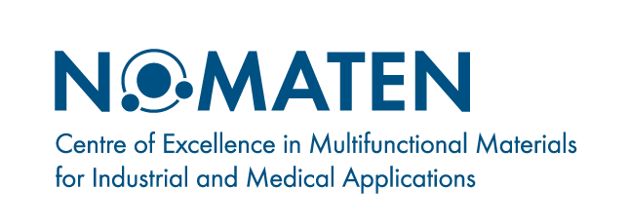

JRC-NOMATEN Workshop
This scientific workshop was delve into the most recent experimental and computational methods in the field of characterization of irradiation damage in materials for extreme operating conditions. Attendees learned about the experimental and computational research carried out by European Commission, DG Joint Research Centre, Nuclear Safety and Security Directorate, Patten the Netherlands and NOMATEN CoE through a series of presentations and discussions. The focus was on numerical simulations and experimental results, with a particular emphasis on several key areas such as:
- Materials Informatics
- Experimental techniques and Multiscale modeling of Nanoindentation
- Irradiation damage in metals, alloys, and oxide dispersion strengthened concentrated solid solution alloys
- Small Punch creep tests and Micromechanical tests
This workshop was a must-attend event for researchers, engineers, and scientists working in material science and radiation engineering, as well as those interested in the development of materials for extreme conditions applications. Participants were encouraged to network on an individual basis, and may use the online platform chat feature during sessions of invited and contributed presentations.

Organizers: Dr. Stefanos Papanikolaou and Dr. Karol Frydrych

PROGRAM: April 6th, 2022
Time (CET) | Participant |  | Title
13:30 | Introductory remarks by Dr. Stefanos Papanikolaou
13:35 | Dr. Kamran Karimi | Descriptors, Machine Learning and Statistics of Pop-In Events
13:55 | Dr. Fabrizio Rovaris | Discrete Dislocation Dynamics and Size Effects in Nanoindentation dynamics
14:15 | Dr. Iwona Jóźwik | Scanning electron microscopy in application to materials characterization
14:35 | Dr. Magdalena Gawęda | Raman spectroscopy and imaging – application in materials science
14:55 | Dr. Javier Dominguez | Atomistic study of radiation damage and dislocation nucleation in BCC metals for fusion applications.
15:15 | Dr. Sri Tapaswi Nori | Study of irradiation effects in oxide dispersion strengthened concentrated solid solution alloys
15:35 | Coffee Break
15:50 | Dr. Elio D’Agata | Neutronic irradiation of structural material: experience and perspective
16:10 | Dr. Karl-Fredrik Nilsson | Strategies for model parameter identification of uniaxial and Small Punch creep tests
16:30 | Dr. Peter Hähner | From small specimen test techniques to micromechanical testing
16:50 | Ms. Cs. Katarzyna Mulewska | Studying elastic-to-plastic transition of polycrystalline pure iron via nanoindentation – pristine case study
17:10 | Dr. Karol Frydrych | Nanoindentation and size effects in continuum modeling

